Day 12 - CareBridge
Patient API Workshop
Cloud-Native Deployment with .NET 8, Docker & Azure

MODULE 01
Business Problem

1.1 Learning Objectives
- Understand why containerisation exists in enterprise engineering
- Articulate the business cost of traditional deployment models
- Connect Docker and Azure adoption to measurable ROI metrics

1.2 The CareBridge Scenario
CareBridge is a mid-size healthcare technology company. Its Patient API serves patient records, appointment data, and lab results to web and mobile clients across 12 hospital branches. The API is the operational backbone of the organisation - any downtime directly affects clinical staff and patient care delivery.

1.2.1 Current State Pain Points
Problem Area | Current Pain | Business Impact
Deployment | Manual IIS deployments on Windows VMs via RDP | 4-hour downtime windows every Saturday night
Scaling | Vertical scaling only - resize the VM | Cost spikes during morning admission hours
Portability | Dev, QA, and Prod use different OS and config | Bugs appear only in Production after go-live
Onboarding | New environment setup requires 2+ days | Slows disaster recovery and new team member ramp-up
Rollback | No versioned deployment artifacts | Rollback requires restoring IIS backup - 60+ minutes

1.3 STAR - The Transformation

Situation
CareBridge's Patient API runs on 3 on-premises Windows VMs. Each deployment requires an engineer to RDP into the server, copy DLL files, modify IIS bindings, and restart the application pool. The process is manual, error-prone, and requires a scheduled 4-hour maintenance window to guarantee rollback capability.

Task
The engineering leadership team commissioned a migration to a cloud-native deployment model. The requirements were explicit: continuous delivery, horizontal autoscaling, full environment parity between development and production, and a rollback time under 5 minutes.

Action
The team containerised the Patient API using Docker, stored images in Azure Container Registry, and deployed to Azure Container Apps. A GitHub Actions pipeline was configured to build, push, and deploy on every merge to the main branch.

Result
Metric | Before Containers | After Containers | Improvement
Deployment Time | 4 hours (manual RDP) | < 5 minutes (pipeline) | 98% faster
Environment Parity Issues | 3-5 per release cycle | Zero | Eliminated
Scale-out Speed | 2-4 hours (VM resize) | Seconds (new replica) | 99% faster
Cost Model | Fixed 24/7 VM cost | Pay-per-request serverless | ~40% reduction
Rollback Time | 60+ minutes | < 2 minutes (image tag) | 97% faster
Saturday Downtime Windows | Required every release | None | Eliminated

MODULE 02  Architecture First | Duration  20 min

2.1 Learning Objectives
- Visualise the complete deployment journey before writing a single line of code
- Understand what each tool does and where it sits in the pipeline
- Build a mental model that all subsequent modules reinforce

2.2 End-to-End Deployment Architecture
Before touching Docker or Azure CLI, every student must understand where each step fits in the overall pipeline.

CareBridge - Complete Cloud-Native Deployment Pipeline
+------------------------------------------+
| DEVELOPER MACHINE |
| Visual Studio 2022 |
| CareBridge.PatientAPI (.NET 8 Web API) |
+------------------------------------------+
|
| docker build -t carebridge-patient-api:v1 .
v
+------------------------------------------+
| DOCKER DESKTOP |
| Local Image: carebridge-patient-api:v1 |
| Runs container locally on port 5000 |
+------------------------------------------+
|
| docker tag + docker push
v
+------------------------------------------+
| AZURE CONTAINER REGISTRY (ACR) |
| acrcarebridge.azurecr.io |
| Private image store in your Azure AD |
+------------------------------------------+
|
| az containerapp create
v
+------------------------------------------+
| AZURE CONTAINER APPS ENVIRONMENT |
| carebridge-env (shared infra layer) |
+------------------------------------------+
|
v
+------------------------------------------+
| AZURE CONTAINER APP |
| carebridge-api |
| Ingress: External / HTTPS |
| Autoscale: 1 to 3 replicas |
| Auto-TLS certificate (managed by Azure) |
+------------------------------------------+
|
v
+------------------------------------------+
| PUBLIC HTTPS ENDPOINT |
| https://<fqdn>.azurecontainerapps.io |
| Accessible worldwide via browser/API |
+------------------------------------------+

2.3 Component Responsibilities
Component | Role in Pipeline | Who Manages It
Visual Studio 2022 | Author the .NET 8 Web API source code | Developer
Docker Desktop | Build and run containers on the local machine | Developer machine
Docker Image | Immutable, versioned package of app and runtime | Created by developer; stored in ACR
Azure Container Registry | Private, secure Docker image repository in Azure | Azure (you provision it)
Container Apps Environment | Shared infrastructure: networking, logging, compute | Azure (fully managed)
Azure Container App | Running application - routing, autoscaling, TLS | Azure (you configure, Azure operates)
Public HTTPS Endpoint | The URL that external clients call to reach the API | Azure (auto-provisioned)

MODULE 03
Docker Fundamentals

3.1 Why Containers Exist
The root problem containers solve has a name: environment drift. Every machine accumulates slightly different OS versions, library versions, and configuration files over time. The outcome is the universally known phrase: 'It works on my machine.'

A container packages the application and its complete runtime environment into a single, portable, immutable unit called an image. When that image runs on any host with a Docker runtime, it behaves identically. Environment drift is eliminated by design.

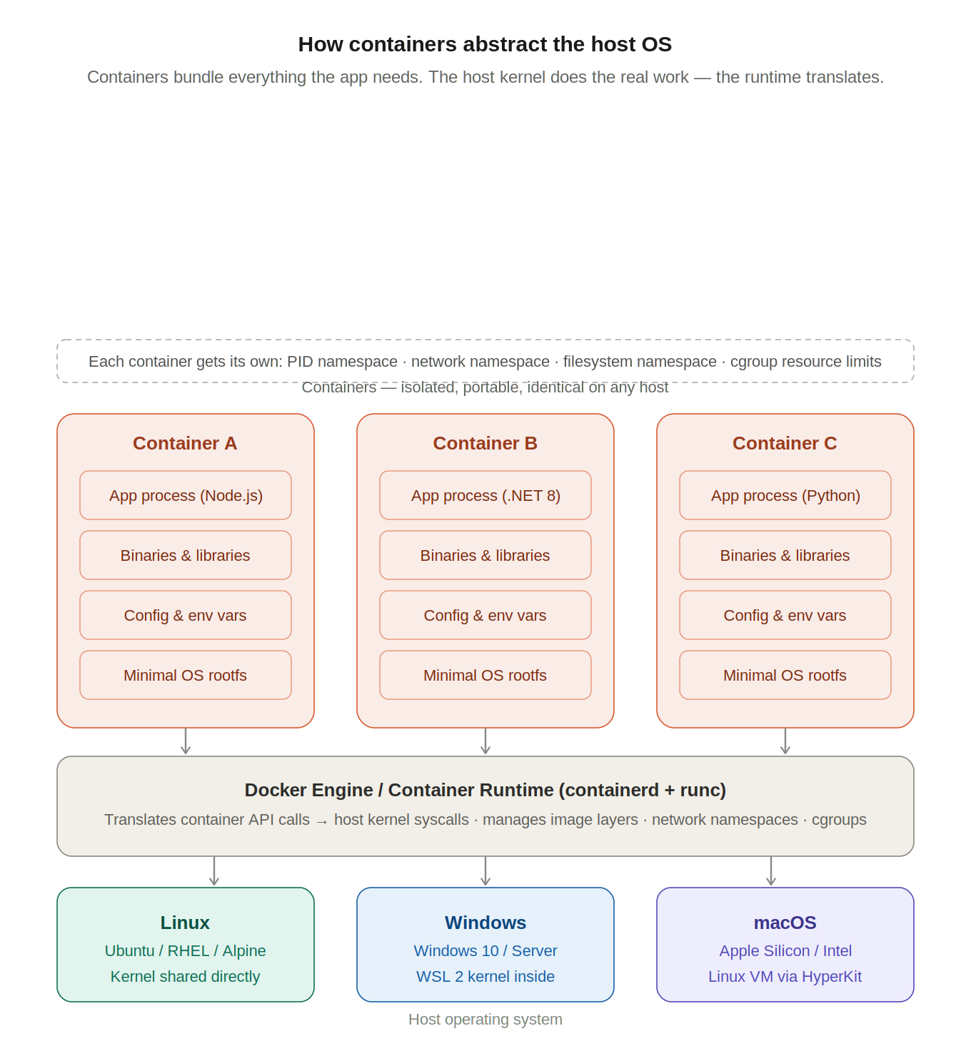

3.2 Virtual Machines vs Containers
Dimension | Virtual Machine | Container
Isolation unit | Entire operating system | Isolated process on shared OS kernel
Image size | Gigabytes (full OS disk image) | Megabytes (app + libraries only)
Start time | Minutes (OS boot sequence) | Milliseconds (process fork)
Portability | Hypervisor-dependent (VMware, Hyper-V) | Runs on any host with Docker Engine
Resource overhead | High - each VM runs a full OS | Low - shared kernel across all containers
Ideal workload | Legacy applications, OS-level isolation | Microservices, APIs, cloud-native apps
Versioning | VM snapshots (large, slow) | Image layers (incremental, fast)
Environment parity | Difficult - VMs drift over time | Guaranteed - image is immutable

3.3 Four Core Docker Concepts
Concept | Definition | Analogy
Dockerfile | Text file with build instructions. Defines every layer of the image. | A recipe for a dish
Image | Read-only, versioned artifact produced by executing the Dockerfile. | The sealed, packaged dish ready to ship
Container | A running instance of an image. Isolated, stateless, disposable. | The dish served and consumed
Registry | Storage and distribution system for images. ACR is Azure's private registry. | The warehouse for sealed packages

3.4 Azure Container Registry
ACR is Microsoft's private, cloud-hosted Docker registry integrated with Azure Active Directory. It replaces Docker Hub for enterprise scenarios where image access must be controlled and audited.

- Authentication: Azure AD identity - no separate registry account required
- Access control: RBAC roles (AcrPush, AcrPull) applied per team or service identity
- Geo-redundancy: replicate images to multiple Azure regions for high availability
- Image scanning: integration with Microsoft Defender for vulnerability assessment
- OCI compliance: stores Docker images, Helm charts, and OCI artifacts

3.5 Azure Container Apps vs AKS
Decision Factor | Azure Container Apps | AKS (Kubernetes)
Infrastructure management | Fully managed serverless | You manage node pools and control plane
Learning curve | Low - focus on the application | High - YAML, namespaces, services, ingress controllers
Time to first public URL | ~5 minutes | 30-60 minutes minimum
Cost model | Pay per vCPU-second consumed | Pay for idle nodes 24/7
Autoscaling | Built-in, KEDA-powered | Requires HPA configuration
TLS certificates | Automatic (managed by Azure) | Requires cert-manager or manual configuration
Best use case | APIs, microservices, workshops | Complex multi-team platform engineering

INDUSTRY BEST PRACTICE | ACA is the correct choice for standalone APIs and event-driven microservices.  AKS becomes the right choice when an organisation manages 20+ services with complex inter-service networking or multi-tenant isolation requirements.

MODULE 04
Visual Studio Build

4.1 Pre-requisite Verification
Run each command in Windows PowerShell before creating the project.

Install Docker Desktop for Windows
https://docs.docker.com/desktop/setup/install/windows-install/


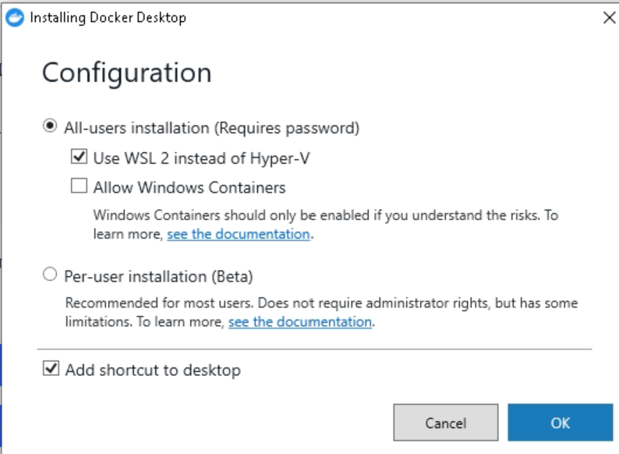
Click OK

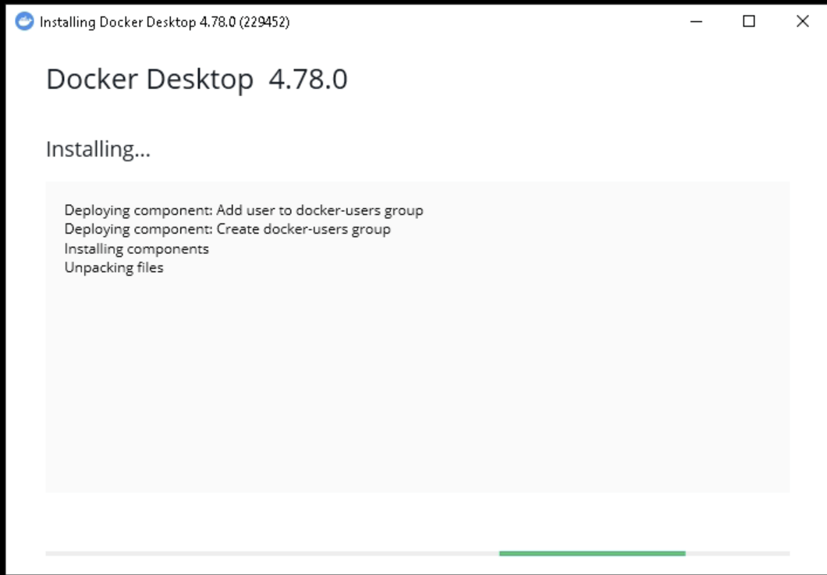
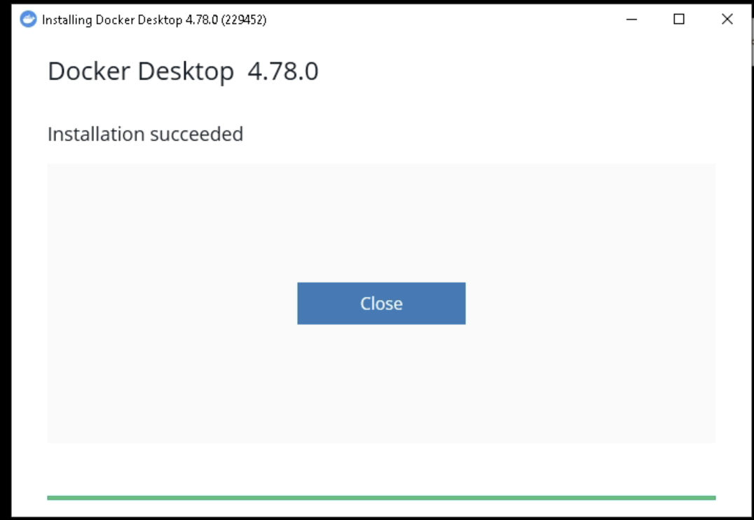
Restart the Lab Machine (Not your official laptop)
Wait for 2-4 minutes, then reconnect

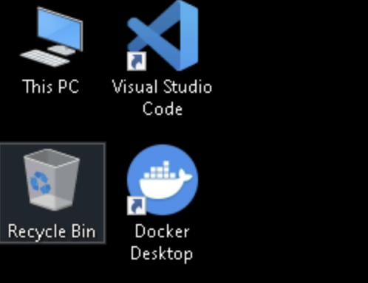
Double click Docker Desktop

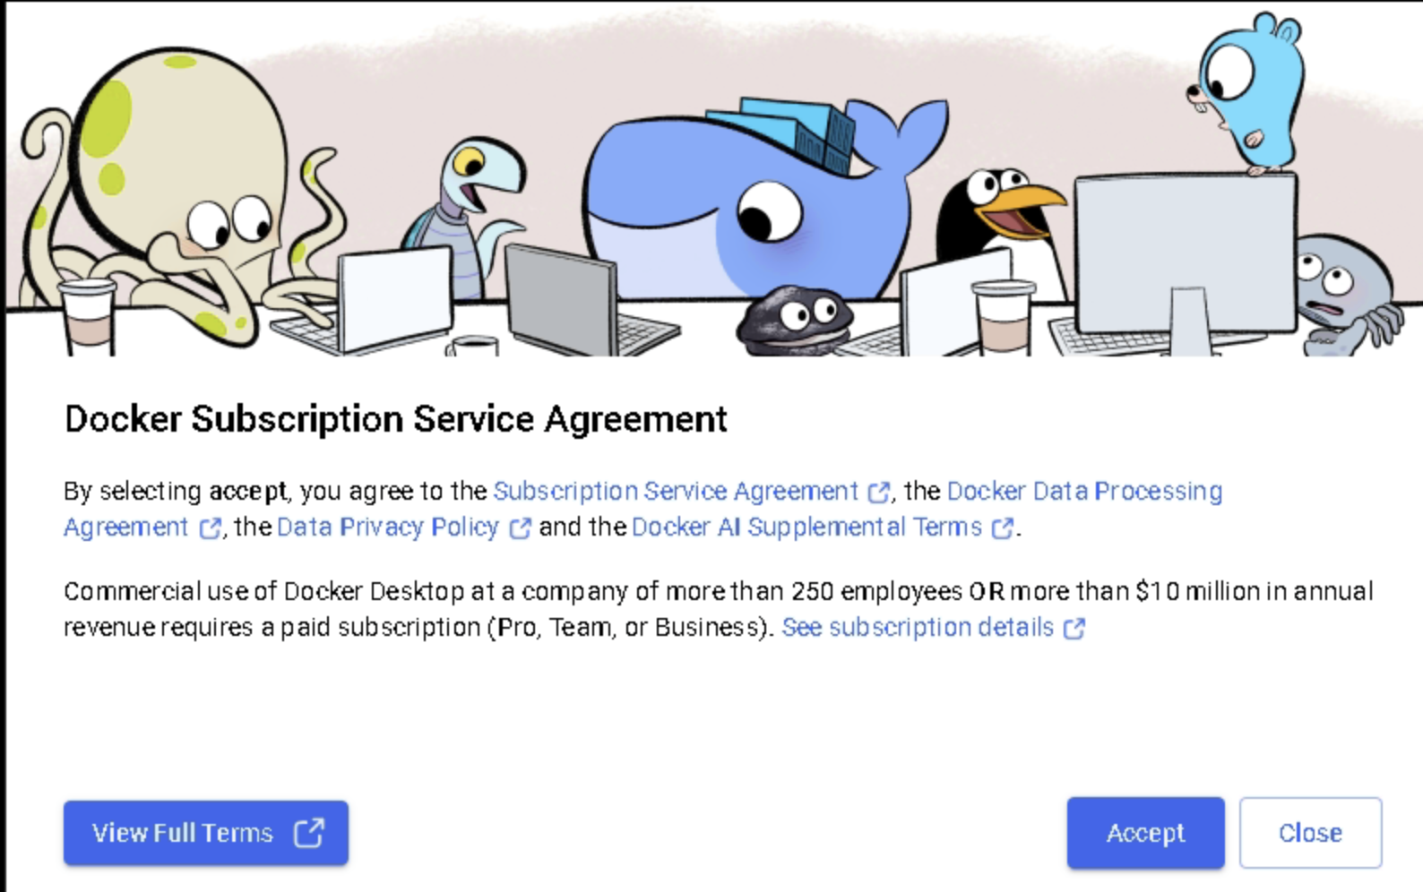
Click Accept

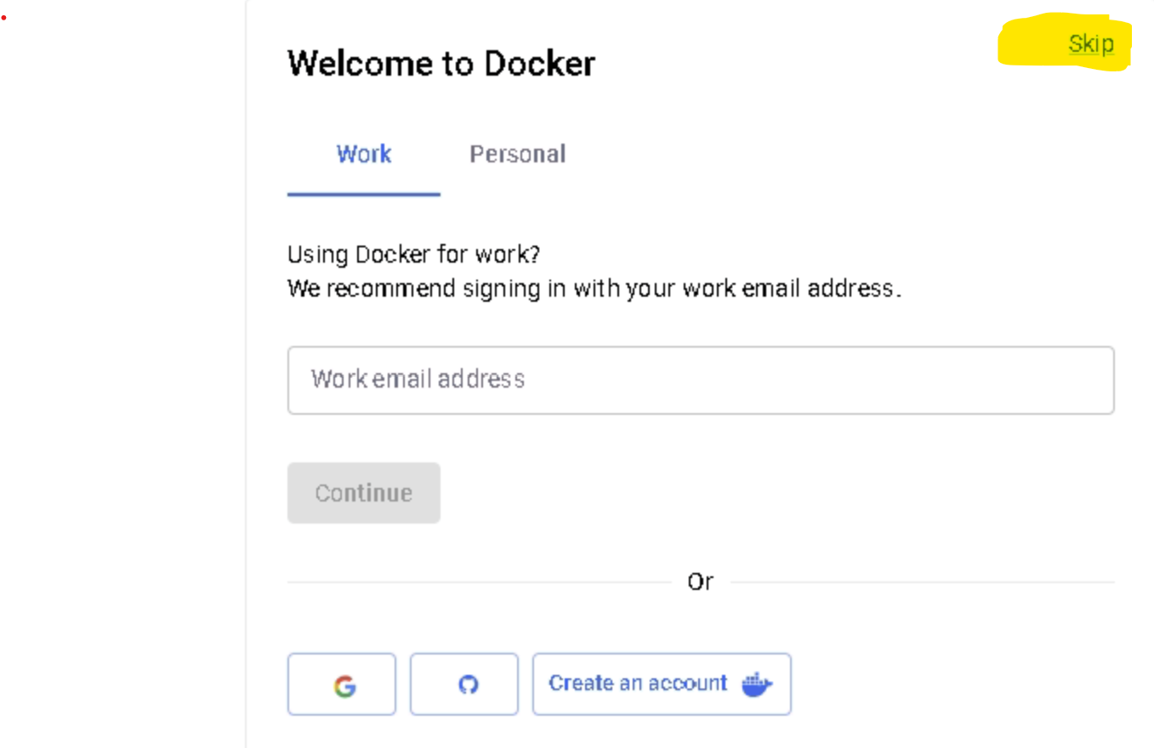
Click Skip

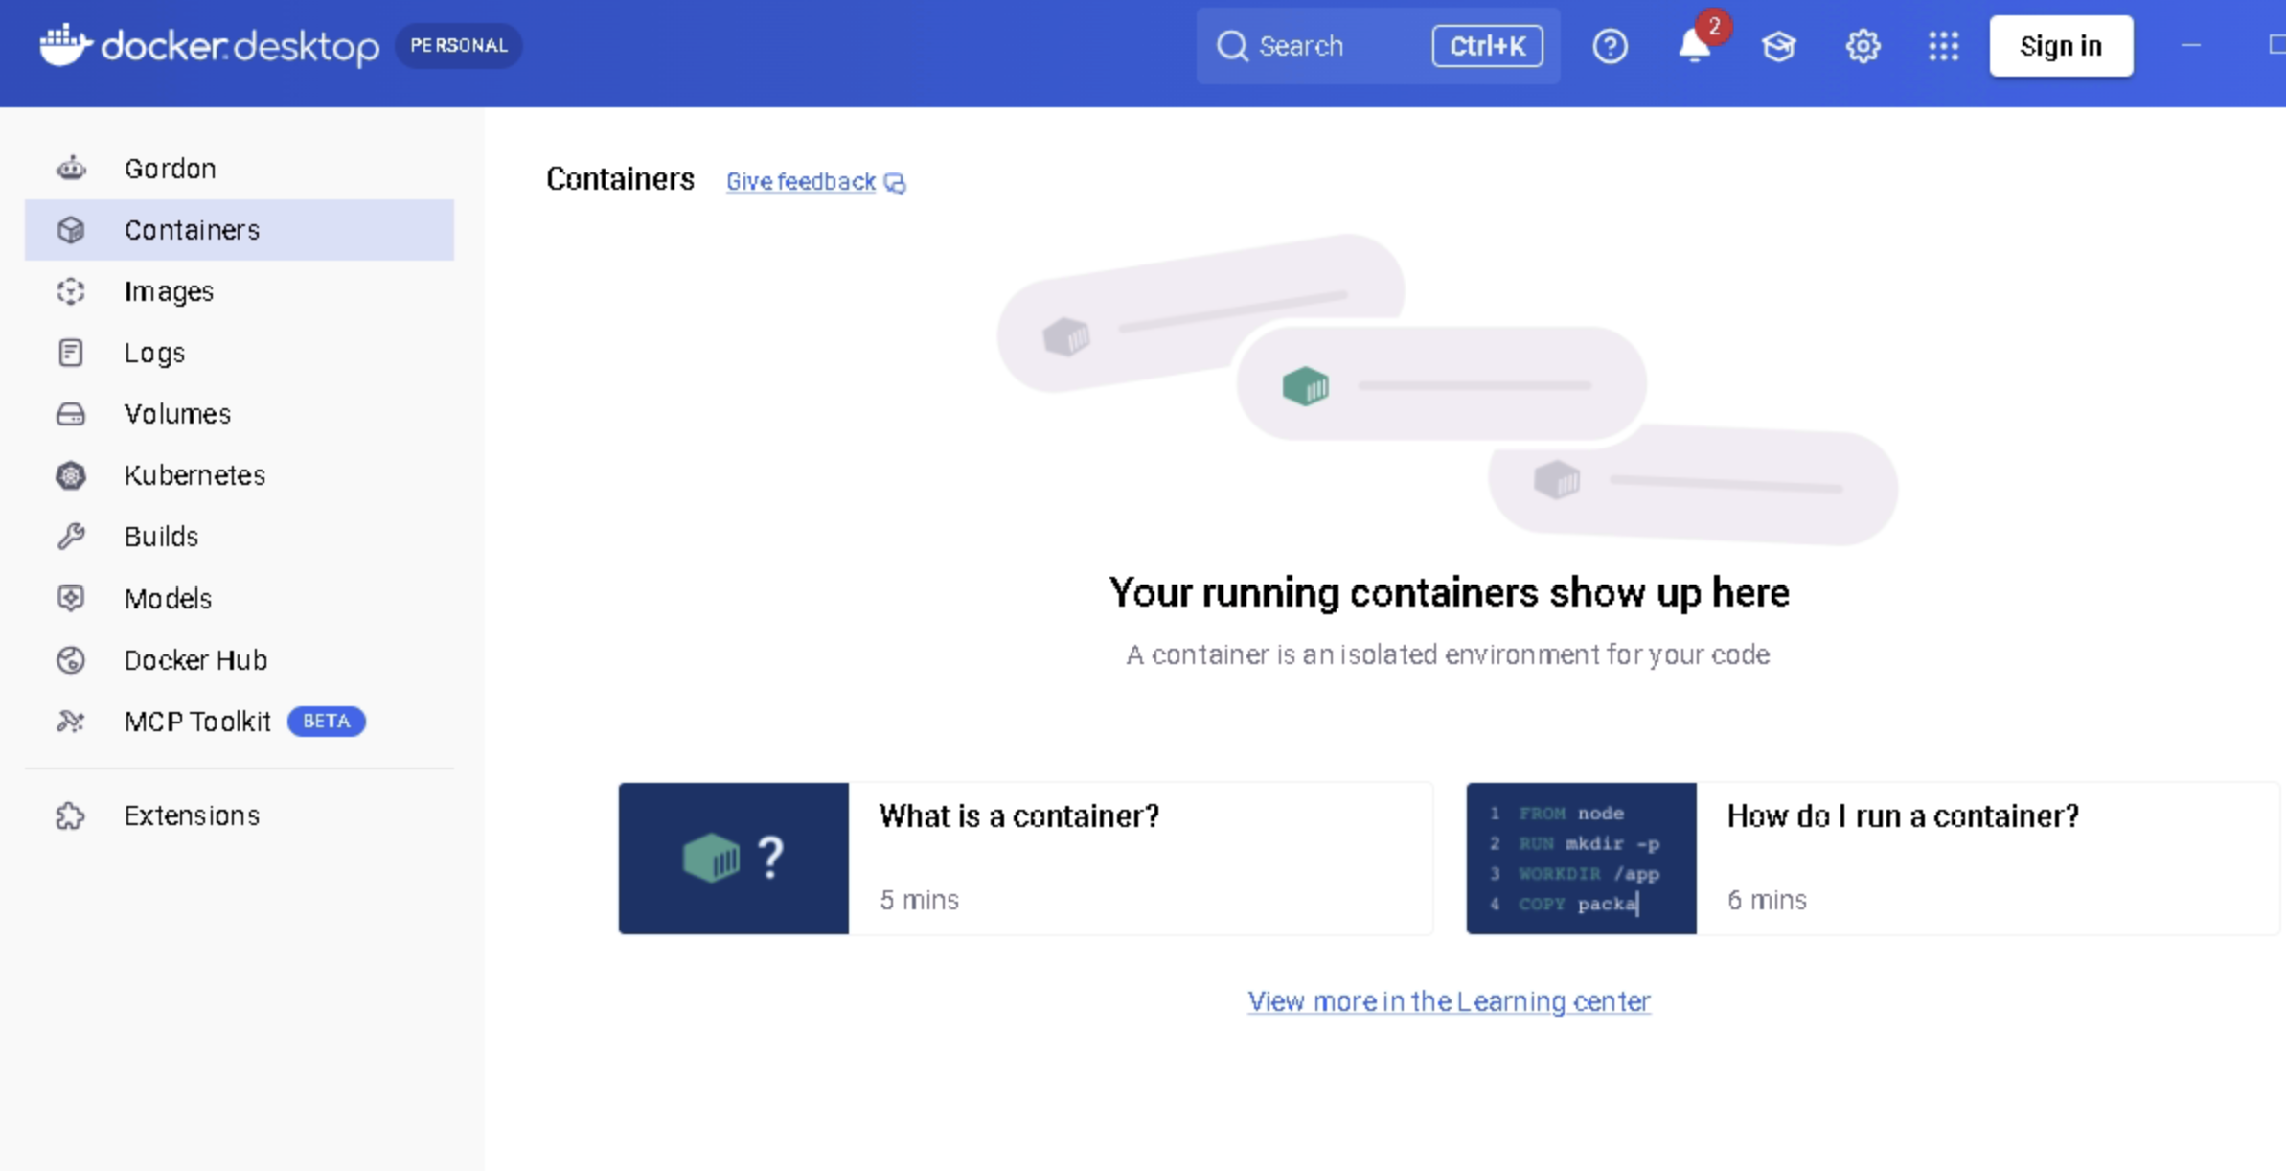

Once docker is installed, machine is rebooted, you may get this error:

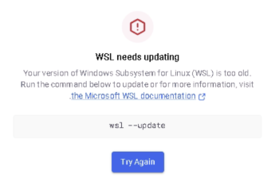

Step 1
Open PowerShell as Administrator and run:
wsl --update
Wait for completion.

Step 2
Check version:
wsl --version
You should see something similar to:
WSL version: 2.x.x
Kernel version: x.x.x
Step 3
Set WSL2 as default:
wsl --set-default-version 2
Step 4
Restart Windows
Step 5
After reconnecting:
wsl --status
Expected: Default Version: 2

Install Azure CLI
https://learn.microsoft.com/en-us/cli/azure/install-azure-cli-windows?view=azure-cli-latest&pivots=msi
or
https://aka.ms/installazurecliwindowsx64


Purpose | Confirm Docker Desktop is installed and the daemon is running.
Purpose | Confirm Azure CLI is installed.

4.2 Create the Visual Studio Project
- Open Visual Studio 2022 and select Create a new project
- Search for ASP.NET Core Web API and select it (not Minimal API)
- Set project name to: CareBridge.PatientAPI
- Set location to: C:\{Your username}\
- Select .NET 8.0 (Long Term Support) as the framework
- Enable: Configure for HTTPS
- Enable: Enable OpenAPI support (Swagger)
- Ensure Controllers is selected - not Minimal APIs
- Click Create

4.3 Project Structure
PROJECT STRUCTURE - CareBridge.PatientAPI
CareBridge.PatientAPI/
├── Controllers/
│ └── PatientController.cs <-- Handles HTTP requests
├── Models/
│ └── Patient.cs <-- Data shape (DTO)
├── Repositories/
│ └── PatientRepository.cs <-- In-memory data store
├── Program.cs <-- App startup and DI config
├── CareBridge.PatientAPI.csproj <-- NuGet and SDK references
├── Dockerfile <-- Container build instructions
└── .dockerignore <-- Files excluded from Docker context

File Dependency Chain
Program.cs
|-- Registers PatientRepository as Singleton
|-- Configures Swagger / OpenAPI
|-- Adds Controllers to the DI container
|
v
PatientController.cs
|-- Receives: HTTP GET / POST requests
|-- Depends on: PatientRepository (constructor injection)
|-- Returns: IActionResult (200 OK, 201 Created, 404 Not Found)
|
v
PatientRepository.cs
|-- Holds: in-memory List<Patient>
|-- Exposes: GetAll() GetById() Add()
|
v
Patient.cs
|-- Properties: Id, FirstName, LastName, DateOfBirth,
| Diagnosis, WardNumber, IsActive

4.4 Patient Model
FILE: Models/Patient.cs
namespace CareBridge.PatientAPI.Models;
public class Patient
{
public int Id { get; set; }
public string FirstName { get; set; } = string.Empty;
public string LastName { get; set; } = string.Empty;
public DateOnly DateOfBirth { get; set; }
public string Diagnosis { get; set; } = string.Empty;
public string WardNumber { get; set; } = string.Empty;
public bool IsActive { get; set; } = true;
}

Property | Type | Purpose
Id | int | Unique identifier; auto-assigned by repository
FirstName | string | Patient first name
LastName | string | Patient last name
DateOfBirth | DateOnly | .NET 8 date-only type - no time component
Diagnosis | string | Primary clinical diagnosis
WardNumber | string | Hospital ward assignment
IsActive | bool | Soft-delete flag - inactive patients excluded from GET /api/patient

4.5 Patient Repository
FILE: Repositories/PatientRepository.cs
using CareBridge.PatientAPI.Models;
namespace CareBridge.PatientAPI.Repositories;
public class PatientRepository
{
private readonly List<Patient> _patients = new()
{
new() { Id=1, FirstName="Arjun", LastName="Sharma",
DateOfBirth=new DateOnly(1985,3,12),
Diagnosis="Hypertension", WardNumber="W-101", IsActive=true },
new() { Id=2, FirstName="Priya", LastName="Nair",
DateOfBirth=new DateOnly(1990,7,25),
Diagnosis="Type 2 Diabetes", WardNumber="W-102", IsActive=true },
new() { Id=3, FirstName="Rahul", LastName="Mehta",
DateOfBirth=new DateOnly(1978,11,8),
Diagnosis="Cardiac Arrhythmia", WardNumber="ICU-1", IsActive=true },
};
public IEnumerable<Patient> GetAll() => _patients;
public Patient? GetById(int id) =>
_patients.FirstOrDefault(p => p.Id == id);
public Patient Add(Patient patient)
{
patient.Id = _patients.Count + 1;
_patients.Add(patient);
return patient;
}
}

4.6 Patient Controller
FILE: Controllers/PatientController.cs
using CareBridge.PatientAPI.Models;
using CareBridge.PatientAPI.Repositories;
using Microsoft.AspNetCore.Mvc;
namespace CareBridge.PatientAPI.Controllers;
[ApiController]
[Route("api/[controller]")]
public class PatientController : ControllerBase
{
private readonly PatientRepository _repo;
public PatientController(PatientRepository repo) => _repo = repo;
/// <summary>Returns all active patients</summary>
[HttpGet]
public IActionResult GetAll() =>
Ok(_repo.GetAll().Where(p => p.IsActive));
/// <summary>Returns a single patient by numeric ID</summary>
[HttpGet("{id:int}")]
public IActionResult GetById(int id)
{
var patient = _repo.GetById(id);
return patient is null ? NotFound() : Ok(patient);
}
/// <summary>Adds a new patient record</summary>
[HttpPost]
public IActionResult Create([FromBody] Patient patient) =>
Created($"/api/patient/{patient.Id}", _repo.Add(patient));
}

Endpoint | HTTP Method | Returns | Status Codes
GET /api/patient | GET | Array of active Patient objects | 200 OK
GET /api/patient/{id} | GET | Single Patient or Not Found | 200 OK | 404 Not Found
POST /api/patient | POST | Created Patient with assigned Id | 201 Created

4.7 Program.cs
FILE: Program.cs
using CareBridge.PatientAPI.Repositories;
var builder = WebApplication.CreateBuilder(args);
// Singleton: one instance shared for the application lifetime
builder.Services.AddControllers();
builder.Services.AddSingleton<PatientRepository>();
builder.Services.AddEndpointsApiExplorer();
builder.Services.AddSwaggerGen(c =>
{
c.SwaggerDoc("v1", new() {
Title = "CareBridge Patient API",
Version = "v1",
Description = "REST API for CareBridge clinical patient management"
});
});
var app = builder.Build();
app.UseSwagger();
app.UseSwaggerUI();
app.UseHttpsRedirection();
app.UseAuthorization();
app.MapControllers();
app.Run();

Run the project (F5). The Swagger UI opens at https://localhost:{port}/swagger.

MODULE 05
Docker Desktop GUI Walkthrough

5.1 Launching Docker Desktop
- Open Start Menu and search for Docker Desktop
- Click to launch. The Docker whale icon appears in the Windows system tray
- Wait until the icon stops animating - this confirms the Docker daemon is running
- The main Docker Desktop window opens to the Containers view

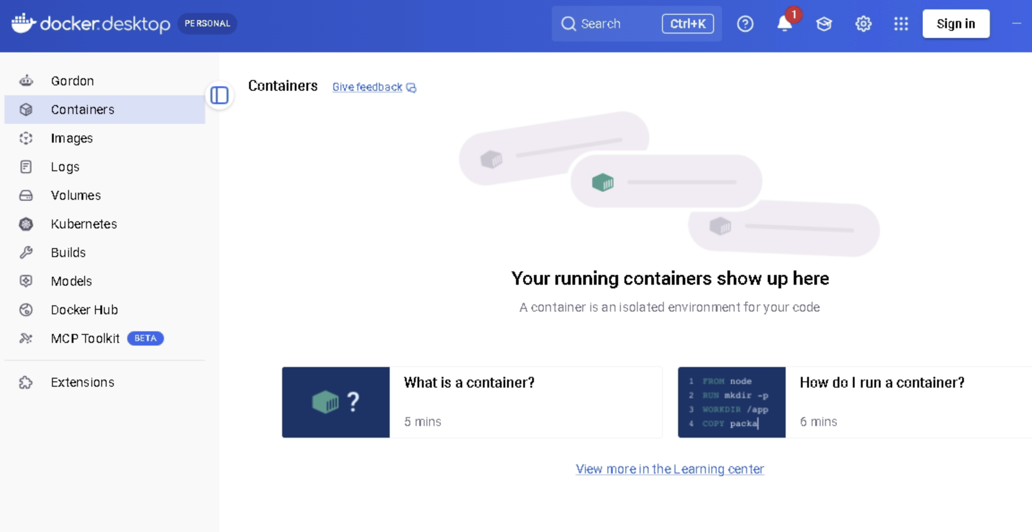

5.2 Viewing Images
Navigation: Docker Desktop → Images (left sidebar)

After this example, build step, the following images will appear in this list:
- carebridge-patient-api:v1 - the application image built from the Dockerfile
- mcr.microsoft.com/dotnet/aspnet:8.0 - the runtime base image from Microsoft
- mcr.microsoft.com/dotnet/sdk:8.0 - the SDK image used during the build stage only

Column | What It Shows
Name | Repository name and tag (e.g. carebridge-patient-api:v1)
Status | In use (container running) or Unused
Created | Timestamp of the most recent build
Size | Compressed disk footprint of the image layers

5.3 Viewing Running Containers
Navigation: Docker Desktop → Containers (left sidebar)

After executing docker run in Module 6, the carebridge-api container appears in this list.
Column | What It Shows
Name | Container name assigned by the --name flag in docker run
Image | The image this container was created from
Status | Running, Exited, or Paused
Port(s) | Host-to-container port mapping (e.g. 5000:8080)
CPU % | Real-time CPU utilisation of the container process
Memory | Current memory consumption

5.4 Starting and Stopping Containers

To Stop a Container
- Navigate to Docker Desktop → Containers
- Locate carebridge-api in the list
- Click the square Stop button on the right side of the row
- The status changes from Running to Exited

To Start a Stopped Container
- Locate the stopped container in the Containers list
- Click the triangle Start button on the right side of the row
- The status returns to Running

To Delete a Container
- Stop the container first
- Click the Delete (trash) icon on the right side of the row
- Confirm deletion in the dialog
MODULE 06
Build and Run Locally

6.1 Write the Dockerfile
Place the Dockerfile in the project root - the same directory as CareBridge.PatientAPI.csproj. In Visual Studio: right-click the project → Add → New Item → select Text File → name it Dockerfile with no extension.

FILE: Dockerfile
# ── STAGE 1: BUILD ──────────────────────────────────────────────────
FROM mcr.microsoft.com/dotnet/sdk:8.0 AS build
WORKDIR /src
# Restore NuGet packages as a cached layer
COPY ["CareBridge.PatientAPI.csproj", "."]
RUN dotnet restore
# Copy remaining source and publish in Release mode
COPY . .
RUN dotnet publish -c Release -o /app/publish
# ── STAGE 2: RUNTIME ─────────────────────────────────────────────────
FROM mcr.microsoft.com/dotnet/aspnet:8.0 AS runtime
WORKDIR /app
# Security: create and switch to non-root OS user
RUN addgroup --system appgroup && adduser --system --ingroup appgroup appuser
USER appuser
# Copy only compiled output from Stage 1
COPY --from=build /app/publish .
EXPOSE 8080
ENV ASPNETCORE_URLS=http://+:8080
ENTRYPOINT ["dotnet", "CareBridge.PatientAPI.dll"]

Instruction | Purpose | Why It Matters
FROM sdk:8.0 AS build | Base image for Stage 1 | Provides compiler, MSBuild, and NuGet tools
COPY .csproj + RUN restore | Restore NuGet packages as a cached layer | Only re-runs when .csproj changes - builds are fast
RUN dotnet publish -c Release | Compile and optimise the application | Release mode enables compiler optimisations
FROM aspnet:8.0 AS runtime | Start fresh with runtime-only image | ASP.NET Runtime ~200 MB vs SDK ~700 MB
RUN adduser appuser | Create a non-root OS user inside the container | Containers running as root are a major attack surface
USER appuser | Switch to non-root user | Prevents privilege escalation if container is compromised
EXPOSE 8080 | Document the container port | Informational only - the -p flag in docker run creates the actual binding
ENV ASPNETCORE_URLS | Configure Kestrel to bind to port 8080 | Overrides default HTTPS binding for internal container traffic
ENTRYPOINT | Command executed when container starts | Launches .NET runtime with the compiled application DLL

FILE: .dockerignore
**/.git
**/.vs
**/.vscode
**/bin
**/obj
**/*.user
**/appsettings.Development.json

Omitting .dockerignore causes Docker to include bin/ and obj/ in the build context. This significantly slows every build and can cause inconsistent image contents. Always create .dockerignore before running docker build.

6.2 Build the Docker Image
Purpose | Navigate to the project directory. All docker commands must be run from the directory containing the Dockerfile.
Command | cd C:\Rahoul Joshii\CareBridge.PatientAPI\CareBridge.PatientAPI
Expected Output | PowerShell prompt changes to: PS C:\Projects\CareBridge.PatientAPI>
Validation | Run: dir Dockerfile - the Dockerfile must appear in the listing.
Troubleshooting | If the directory does not exist, check the project location set during Visual Studio project creation.

Purpose | Build the Docker image from the Dockerfile in the current directory. The -t flag assigns a name and tag.
Command | docker build -t carebridge-patient-api:v1 .
Expected Output | Successfully tagged carebridge-patient-api:v1  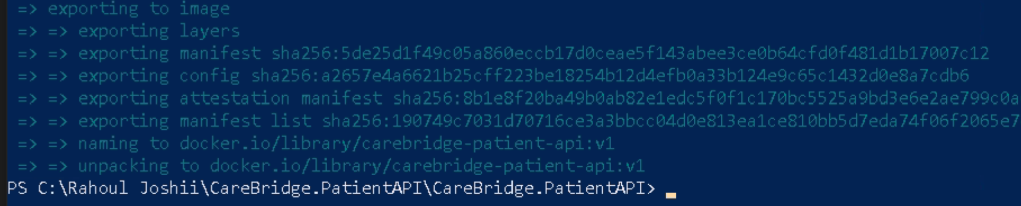
Validation | Run: docker images carebridge-patient-api - the image must appear with tag v1.

6.3 Run the Container Locally
Purpose | Start the container in detached mode, assign a name, and map host port 5000 to container port 8080.
Command | docker run -d --name carebridge-api -p 5000:8080 carebridge-patient-api:v1
Expected Output | A container ID string (long hex value)
Validation | Run: docker ps - carebridge-api must appear with status Up and ports 0.0.0.0:5000->8080/tcp.

6.4 Test the Running Container
Purpose | Confirm the API is responding to HTTP requests.
Command | curl http://localhost:5000/api/patient
Expected Output | [{"id":1,"firstName":"Arjun","lastName":"Sharma",...},{"id":2,...}]

Purpose | Retrieve a single patient by ID to verify the parameterised GET endpoint.
Command | curl http://localhost:5000/api/patient/1
Expected Output | {"id":1,"firstName":"Arjun","lastName":"Sharma","diagnosis":"Hypertension",...}
Validation | HTTP 200 must be returned. Test with /api/patient/99 - must return 404.

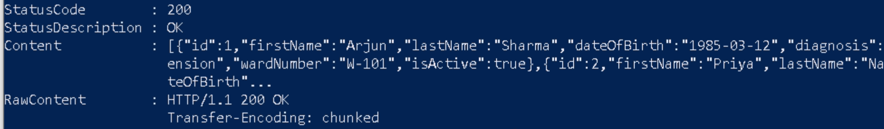
MODULE 07
Azure Walkthrough

Single-Line Command Requirement
All Azure CLI commands in this module are formatted as single-line commands. Do not add line breaks. Copy each command exactly as shown from the Command field and paste it into PowerShell.

Authenticate to Azure
Purpose | Authenticate the Azure CLI with your Azure account.  Start Powershell on Windows
Command | az login
Expected Output | A list of available subscriptions in JSON format. The browser authentication tab closes automatically.

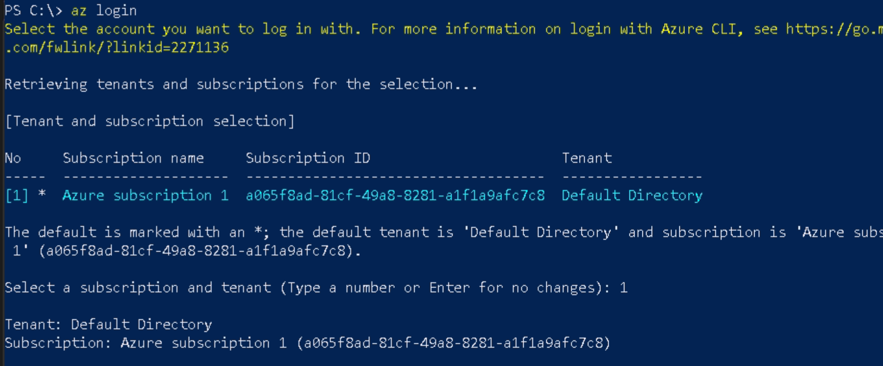

8.3 Create Resource Group (Ignore – Done Above in GUI)
Purpose | Create a Resource Group to contain all Azure resources.
Command | az group create --name RG-CareBridge --location eastus

8.4 Create Azure Container Registry (Ignore – Done Above in GUI)
Purpose | Create a private Docker image registry in Azure.
Command | az acr create --resource-group RG-CareBridge --name acrcarebridge --sku Basic --admin-enabled true
Expected Output | JSON with: "provisioningState": "Succeeded" and "loginServer": "acrcarebridge.azurecr.io"

Run this
Purpose | Authenticate Docker to the Azure Container Registry.
Command | az acr login --name acrcarebridge
Expected Output | Login Succeeded
Validation | Output must say Login Succeeded. Any other message indicates an authentication failure.

8.5 Tag and Push the Image
Purpose | Tag the local image with the full ACR registry path for upload.  docker images
Command | docker tag carebridge-patient-api:v1 acrcarebridge.azurecr.io/carebridge-patient-api:v1
Expected Output | No output on success.

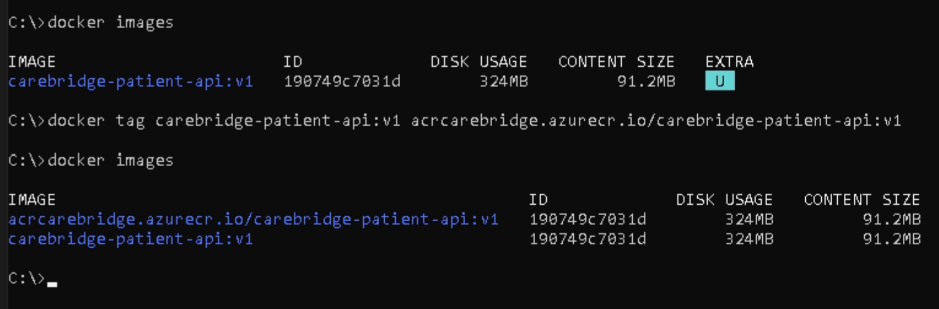

Purpose | Upload the tagged image to Azure Container Registry.
Command | docker push acrcarebridge.azurecr.io/carebridge-patient-api:v1
Expected Output | v1: digest: sha256:abc123... size: XXXX
Validation | Azure Portal → Container Registries → acrcarebridge → Repositories - carebridge-patient-api must appear.

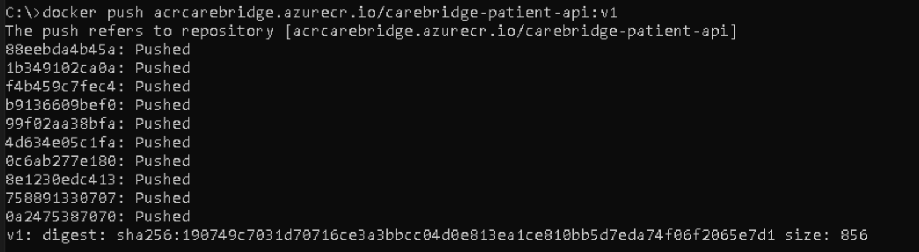

7.4 Create Container Apps Environment
The Container Apps Environment is the shared infrastructure layer for all Container Apps. It manages networking, logging, and underlying compute.

MODULE 08
Azure CLI Deployment

8.6 Deploy to Azure Container Apps
Purpose | Install the Azure Container Apps CLI extension.
Command | az extension add --name containerapp --upgrade
Expected Output | Extension containerapp installed or updated.

Purpose | Register the Microsoft.App resource provider required for Container Apps.
Command | az provider register --namespace Microsoft.App
Expected Output | Registering is still on-going. Use az provider show to check the registration state.
Troubleshooting | Registration takes 2-5 minutes.

Purpose | Register the Microsoft.OperationalInsights provider for Log Analytics.
Command | az provider register --namespace Microsoft.OperationalInsights
Expected Output | Registering is still on-going.
Validation | Run: az provider show --namespace Microsoft.OperationalInsights --query registrationState --output tsv
Troubleshooting | Allow 2-5 minutes for registration to complete before proceeding.

Purpose | Create the shared infrastructure environment for all Container Apps.
Command | az containerapp env create --name carebridge-env --resource-group RG-CareBridge --location eastus
Expected Output | JSON with: "provisioningState": "Succeeded"  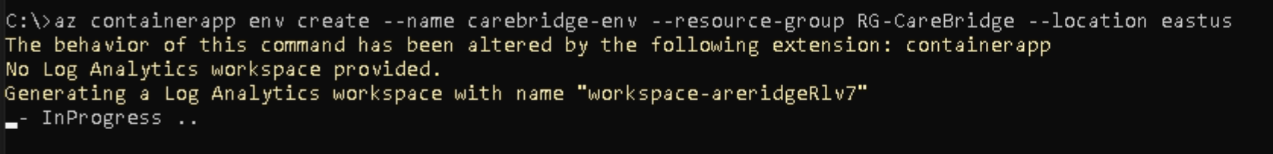
Validation | Azure Portal → Container Apps Environments → carebridge-env must appear.

Purpose | Create and deploy the CareBridge Container App with autoscaling, ingress, and ACR credentials.
Command | az containerapp create --name carebridge-api --resource-group RG-CareBridge --environment carebridge-env --image acrcarebridge.azurecr.io/carebridge-patient-api:v1 --registry-server acrcarebridge.azurecr.io --registry-username $(az acr credential show --name acrcarebridge --query username -o tsv) --registry-password $(az acr credential show --name acrcarebridge --query passwords[0].value -o tsv) --target-port 8080 --ingress external --cpu 0.5 --memory 1Gi --min-replicas 1 --max-replicas 3
Expected Output | JSON object with Container App configuration including FQDN in: properties.configuration.ingress.fqdn  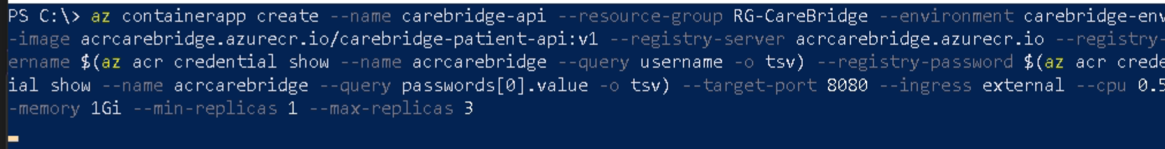
Validation | Azure Portal → Container Apps → carebridge-api must appear with status Running.

Parameter | Value | Purpose | Business Explanation
az | Azure CLI | Azure command line tool | Used to manage Azure resources from terminal
containerapp | Service Name | Azure Container Apps service | Serverless container hosting platform
create | Action | Creates a new Container App | Deploys application into Azure
--name | carebridge-api | Container App Name | Name visible in Azure Portal
--resource-group | RG-CareBridge | Resource Group | Logical folder containing Azure resources
--environment | carebridge-env | Container Apps Environment | Shared infrastructure for Container Apps
--image | acrcarebridge.azurecr.io/carebridge-patient-api:v1 | Docker Image | Application package to run
--registry-server | acrcarebridge.azurecr.io | Container Registry URL | Location where Docker image is stored
--registry-username | Dynamic Value | ACR Login Username | Authenticates Azure before pulling image
--registry-password | Dynamic Value | ACR Login Password | Secure access to private registry
--target-port | 8080 | Internal Application Port | Port where ASP.NET Core listens
--ingress | external | Internet Accessibility | Makes API publicly accessible
--cpu | 0.5 | CPU Allocation | Half vCPU allocated to container
--memory | 1Gi | Memory Allocation | 1 GB RAM allocated
--min-replicas | 1 | Minimum Instances | Keeps at least one container running
--max-replicas | 3 | Maximum Instances | Auto-scales up to 3 containers

MODULE 09
Verification and Testing

9.1 Retrieve the Public URL
Purpose | Retrieve the fully qualified domain name of the deployed Container App.
Command | az containerapp show --name carebridge-api --resource-group RG-CareBridge --query properties.configuration.ingress.fqdn --output tsv
Expected Output | carebridge-api.thankfulground-abc12345.eastus.azurecontainerapps.io
Validation | Copy this URL. Open browser: https://<fqdn>/swagger

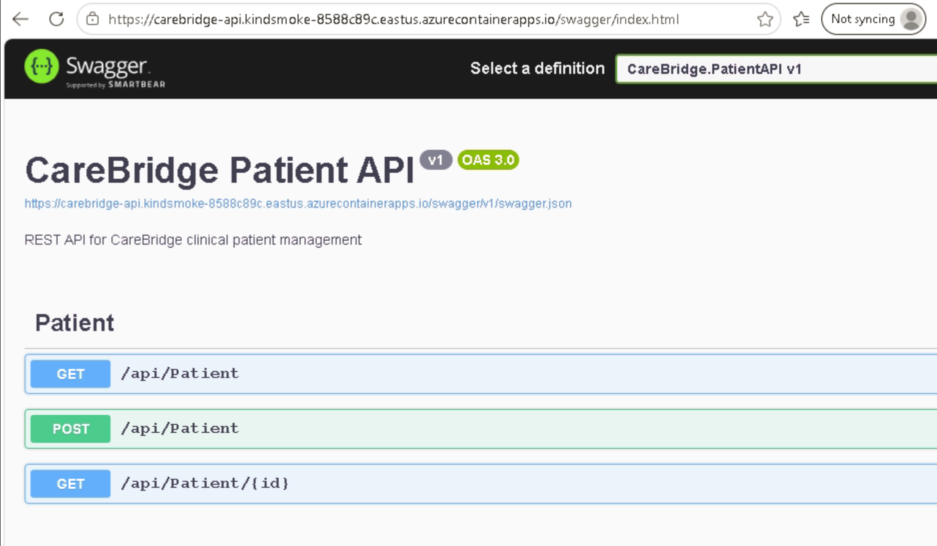

9.2 Verification Checklist
Checkpoint | How to Verify | Expected Result
ACR contains image | Portal: ACR → Repositories | carebridge-patient-api:v1 listed
Container App created | Portal: Container Apps → carebridge-api | Status: Running
Public URL accessible | Browser: https://<fqdn>/swagger | Swagger UI loads
GET /api/patient responds | curl https://<fqdn>/api/patient | JSON array of 3 patients
GET by ID responds | curl https://<fqdn>/api/patient/1 | Single patient JSON object
Logs streaming | az containerapp logs show --follow | HTTP request logs appear
Autoscale configured | Portal: Container Apps → Scale | Min: 1, Max: 3 replicas

MODULE 10
Cost Optimisation

10.1 Cost Estimate
Resource | SKU | 3-Hour Training Cost | Monthly If Left Running | Priority
Azure Container Registry | Basic | ~$0.05 | ~$5.00/month | High
Azure Container Apps | Consumption | ~$0.10 | ~$2-8/month | High
Log Analytics Workspace | Pay-as-you-go | ~$0.01 | ~$0-5/month | Medium
Total |  | ~$0.20 | ~$7-18/month

PRODUCTION REALITY | In enterprise environments, Container Apps in Consumption plan with min-replicas 0 incur zero cost when idle.  For training environments, always configure min-replicas 0 to eliminate idle costs.

Hosting Option | Approx Monthly Cost | Scale to Zero | Complexity | Best Use Case
Azure Container Apps (Consumption) | $7–18/month | Yes | Low | Training, demos, small production workloads
Azure App Service S1 | $80–85/month | No | Very Low | Simple ASP.NET Core hosting, Visual Studio Publish
Azure App Service S2 | $150/month | No | Very Low | Higher traffic applications requiring more CPU/RAM
Azure Kubernetes Service (AKS) | $80–250+/month | No | High | Enterprise microservices, Kubernetes learning, production platforms

Recommendation for CareBridge Training
- Container Apps: Lowest cost, modern cloud-native deployment
- App Service S1: Simplest deployment experience; students can publish directly from Visual Studio.
- App Service S2: Usually unnecessary for training labs.
- AKS: Powerful but adds significant operational complexity and cost

10.2 Cleanup Commands
Purpose | Delete the Resource Group and all resources inside it - ACR, Container Apps Environment, and the Container App - in a single operation.
Command | az group delete --name RG-CareBridge --yes --no-wait
Expected Output | No output. Deletion runs in the background.
Validation | Run: az group show --name RG-CareBridge - must return ResourceGroupNotFound after 2-5 minutes.
Troubleshooting | ResourceGroupNotFound - the group was already deleted or does not exist.

Purpose | Remove local Docker images to free disk space.
Command | docker rmi carebridge-patient-api:v1
Expected Output | Untagged: carebridge-patient-api:v1
Validation | Run: docker images - carebridge-patient-api must no longer appear.
Troubleshooting | conflict: unable to remove - stop all containers using this image first with: docker stop carebridge-api

Purpose | Remove all stopped containers, unused images, and unused networks.

Quick Reference Cheat Sheet

Essential Docker Commands
Command | Purpose
docker build -t name:tag . | Build image from Dockerfile in current directory
docker images | List all local images
docker run -d --name app -p 5000:8080 name:tag | Run container in background; map host:container ports
docker ps | List running containers
docker ps -a | List all containers including stopped
docker logs -f container_name | Stream live logs from container
docker exec -it container_name /bin/bash | Open interactive shell inside container
docker stop container_name | Gracefully stop a running container
docker rm container_name | Remove a stopped container
docker rm -f container_name | Force-remove a running container
docker rmi image_name:tag | Remove a local image
docker system prune -f | Remove all unused containers, images, networks
docker inspect container_name | View full container configuration as JSON
docker tag source:tag dest:tag | Create an alias tag for an existing image
docker push registry/image:tag | Upload image to a remote registry

Essential Azure CLI Commands
Command | Purpose
az login | Authenticate to Azure via browser
az login --use-device-code | Authenticate via device code - no browser required
az account list --output table | List available subscriptions
az account set --subscription "name" | Set the active subscription
az group create --name X --location eastus | Create a resource group
az group delete --name X --yes --no-wait | Delete resource group and all resources
az acr create --name X --resource-group Y --sku Basic | Create Azure Container Registry
az acr login --name X | Authenticate Docker to ACR
az acr repository list --name X | List all repositories in ACR
az acr repository show-tags --name X --repository Y | List all tags for a specific repository
az extension add --name containerapp --upgrade | Install or update Container Apps CLI extension
az provider register --namespace Microsoft.App | Register the Container Apps resource provider
az containerapp env create --name X --resource-group Y --location eastus | Create Container Apps Environment
az containerapp create --name X ... | Deploy a new Container App
az containerapp update --name X --image Y | Update Container App with a new image
az containerapp show --name X --resource-group Y | View Container App configuration and FQDN
az containerapp logs show -n X -g Y --follow | Stream live logs from Container App
az containerapp list --output table | List all Container Apps in the subscription

Term | Definition
ACA | Azure Container Apps - serverless container hosting platform from Microsoft
ACR | Azure Container Registry - private Docker image storage in Azure
Container | An isolated, lightweight process bundling application and runtime into a portable unit
Dockerfile | Text file with sequential build instructions for creating a Docker image
Docker Desktop | GUI application running the Docker daemon on Windows or macOS developer machines
Environment drift | The accumulation of configuration differences between development and production over time
FQDN | Fully Qualified Domain Name - the complete public URL of a deployed application
Image | Read-only, versioned artifact produced by executing a Dockerfile
Ingress | Inbound network traffic configuration for a Container App - external or internal
Kestrel | ASP.NET Core's built-in cross-platform HTTP server
Managed Identity | An Azure AD identity automatically managed by Azure - no credentials to store or rotate
Multi-stage build | Dockerfile pattern using multiple FROM instructions to minimise final image size
Non-root user | OS user without administrative privileges - the security standard for container processes
OCI | Open Container Initiative - the open standard for container image format and runtime
RBAC | Role-Based Access Control - Azure's permission model using roles assigned to identities
Registry | A storage and distribution system for container images
SKU | Service tier determining feature set and price (e.g. Basic, Standard, Premium)
TLS | Transport Layer Security - the protocol providing HTTPS encryption

Aspect | GitHub | Docker Hub | Azure Equivalent
Primary Purpose | Store source code | Store container images | GitHub ↔ Azure DevOps Repos, Docker Hub ↔ Azure Container Registry (ACR)
Stores | .cs, .js, .sql, source files | Docker images (.NET API image, Node image, etc.) | Azure Repos / ACR
Used By | Developers | DevOps, Cloud Engineers | Azure DevOps / ACR
Example | CareBridge.PatientAPI source code | carebridge-patient-api:v1 image | Azure Repos + ACR
Versioning | Git commits, branches, tags | Image tags (v1, v2, latest) | Git + ACR Tags
Collaboration | Pull Requests, Code Reviews | Image sharing and distribution | Azure DevOps
CI/CD Integration | GitHub Actions | Receives images from pipelines | Azure Pipelines
Security | Branch protection, code scanning | Image scanning, private repositories | Microsoft Defender + ACR
Public/Private | Both | Both | Both
Typical URL | github.com/company/project | hub.docker.com | dev.azure.com / *.azurecr.io

When Do We Use Each?
Scenario | GitHub | Docker Hub | Azure Service
Writing application code | ✅ | ❌ | Azure Repos
Source control | ✅ | ❌ | Azure Repos
Build pipeline trigger | ✅ | ❌ | GitHub Actions / Azure Pipelines
Store Docker images | ❌ | ✅ | Azure Container Registry
Deploy to Azure Container Apps | Indirectly | Indirectly | Azure Container Apps
Store Kubernetes images | ❌ | ✅ | ACR
Enterprise production workloads | Limited | Possible | ACR (Preferred)

Pros and Cons
Tool | Pros | Cons
GitHub | Excellent source control, collaboration, PRs, Actions, huge ecosystem | Does not store runnable container artifacts
Docker Hub | Simple, global image repository, huge public image catalog | Rate limits, weaker enterprise governance
Azure Container Registry (ACR) | Azure AD integration, RBAC, private networking, geo-replication, vulnerability scanning | Azure-specific, slightly higher cost than Docker Hub

GitHub stores the recipe (source code), Docker Hub/ACR stores the packaged meal (container image), and Azure Container Apps serves the meal to customers.

